|  |
| --- |
| Close-up image showing the leaf-sides of two oversized books side-by-side on a bookshelf, with additional books in soft focus background |
| Individual Project: Executive Summary  Risk Assessment and Disaster Recovery Plan |
| |  |  |  | | --- | --- | --- | | Milad Chowdhury | 1/18/25 | Security and Risk Management October 2024 | |

Contents

Executive Summary: Risk Assessment and Disaster Recovery Plan 2

1. Introduction 2

2. Risk Analysis: Potential Risks to Quality and Supply Chain 2

2.1 Identifying Key Risks 2

2.2 Quantitative Risk Modelling 3

2.3 Graphical Representation of Risk Probabilities 3

3. Business Continuity and Disaster Recovery (DR) Strategy 4

3.1 Disaster Recovery Planning 4

3.2 DR Testing and Maintenance 5

3.3 Communication and Stakeholder Engagement 5

4. Legal and Ethical Considerations 5

4.1 Data Privacy and Protection 5

4.2 Ethical Use of Artificial Intelligence (AI) 5

4.3 Environmental Sustainability 6

4.4 Implementation Timeline 6

5. Conclusion 8

References 9

# Executive Summary: Risk Assessment and Disaster Recovery Plan

# 1. Introduction

Cathy’s company is undergoing a digital transformation to enhance operational capabilities and meet the demands of a growing international clientele. Key initiatives include:

* **Supply Chain Expansion**: Integrating global markets and automated warehouse solutions.
* **Efficiency Optimisation**: Catering to high-profile clients, including HRH the King and Prince Albert II of Monaco.

The project leveraged:

* **Collaborative Efforts**: Synthesising industry best practices and innovative disaster recovery frameworks.
* **Risk Identification**: Addressing supply chain disruptions, cybersecurity threats, and quality control failures.
* **Advanced Methodologies**: Monte Carlo simulations for risk quantification and adherence to GDPR, ISO 27001, and NIST standards.

This executive summary focuses on scalability, cost-efficiency, and operational resilience to position Cathy’s company as a global market leader (Kumar, 2021; World Bank, 2023; Yamamoto, 2020).

# 2. Risk Analysis: Potential Risks to Quality and Supply Chain

## 2.1 Identifying Key Risks

**Supply Chain Disruptions:** Geopolitical tensions, customs delays, and transportation bottlenecks can significantly impact delivery times and operational efficiency. For instance, unexpected political instability or trade disputes in key supplier countries can delay sourcing raw materials or finished goods. Additionally, reliance on just-in-time inventory systems exacerbates the impact of these disruptions, increasing the risk of stockouts during peak demand periods (World Bank, 2023).

**Quality Control Failures:** Automation errors in warehouses may lead to product inconsistencies and reduced quality standards. Automated systems, while efficient, are prone to calibration issues and software glitches. If undetected, these errors can result in defective products reaching customers, eroding trust, and tarnishing the brand’s reputation. Ensuring rigorous monitoring systems and periodic quality audits across automated facilities is essential to mitigate this risk (Yamamoto, 2020).

**Cybersecurity Threats:** The digitisation process increases exposure to data breaches, ransomware attacks, and supply chain cyber vulnerabilities. Cyberattacks targeting supplier networks or operational data can disrupt critical processes, including order fulfilment and customer service. Recent reports highlight that ransomware attacks on retail supply chains have risen 34% in the past year alone, emphasising the need for robust cybersecurity frameworks and regular threat assessments (ENISA, 2022).

**Vendor Lock-In:** Over-reliance on single suppliers poses risks to flexibility and operational control. Dependency on a single vendor for critical operations, such as cloud services or key components, can lead to inflated costs and delays if the vendor experiences operational challenges. Diversifying the supplier base and negotiating flexible contract terms are vital strategies to mitigate this risk (Kumar, 2021).

## 2.2 Quantitative Risk Modelling

Quantitative risk analysis was conducted using Monte Carlo simulation, a statistical technique that evaluates potential risks by running numerous simulations to estimate the likelihood and impact of various scenarios. This approach is efficient in complex environments like Cathy’s digitised, globalised supply chain, where uncertainties stem from multiple sources. The following table outlines the risk factors identified:

|  |  |  |  |
| --- | --- | --- | --- |
| **Risk Factor** | **Probability (%)** | **Impact on Product Quality (%)** | **Impact on Supply Chain (%)** |
| Supply Chain Delays | 20 | Moderate (15-25) | High (30-35) |
| Quality Control Failures | 15 | High (25-35) | Low (5-10) |
| Cybersecurity Breaches | 10 | Moderate (10-15) | Moderate (15-20) |

Monte Carlo simulations provide Cathy’s company with actionable insights, enabling prioritisation of mitigation strategies. The method also highlights the compounded risks when multiple factors coincide, such as delays exacerbated by cyberattacks, emphasising the need for a layered and adaptive risk management approach.

## 2.3 Graphical Representation of Risk Probabilities

The following bar chart visually represents the probabilities of each identified risk, offering valuable insights into their potential impact on operations. By illustrating the likelihood of risks such as supply chain delays, quality control failures, and cybersecurity breaches, the chart helps prioritise mitigation efforts. For example:

* **Supply Chain Delays:** The chart highlights a 20% probability of delays, indicating the need for initiative-taking measures like diversifying suppliers and enhancing logistical flexibility.
* **Quality Control Failures:** A 15% probability reflects a significant risk to product quality, emphasising the importance of robust monitoring and regular calibration of automated systems.
* **Cybersecurity Breaches:** Although less likely at 10%, their moderate impact on product quality and supply chain underscores the importance of strong cybersecurity defences.

# 3. Business Continuity and Disaster Recovery (DR) Strategy

To mitigate these risks and maintain operational stability, Cathy’s company must implement a robust DR strategy with the following critical requirements:

* **Availability:** Ensure uninterrupted operations 24/7/365.
* **Recovery Time Objective (RTO):** Implement a one-minute recovery window during disruptions.
* **Recovery Point Objective (RPO):** Guarantee that no more than one minute of data is lost.

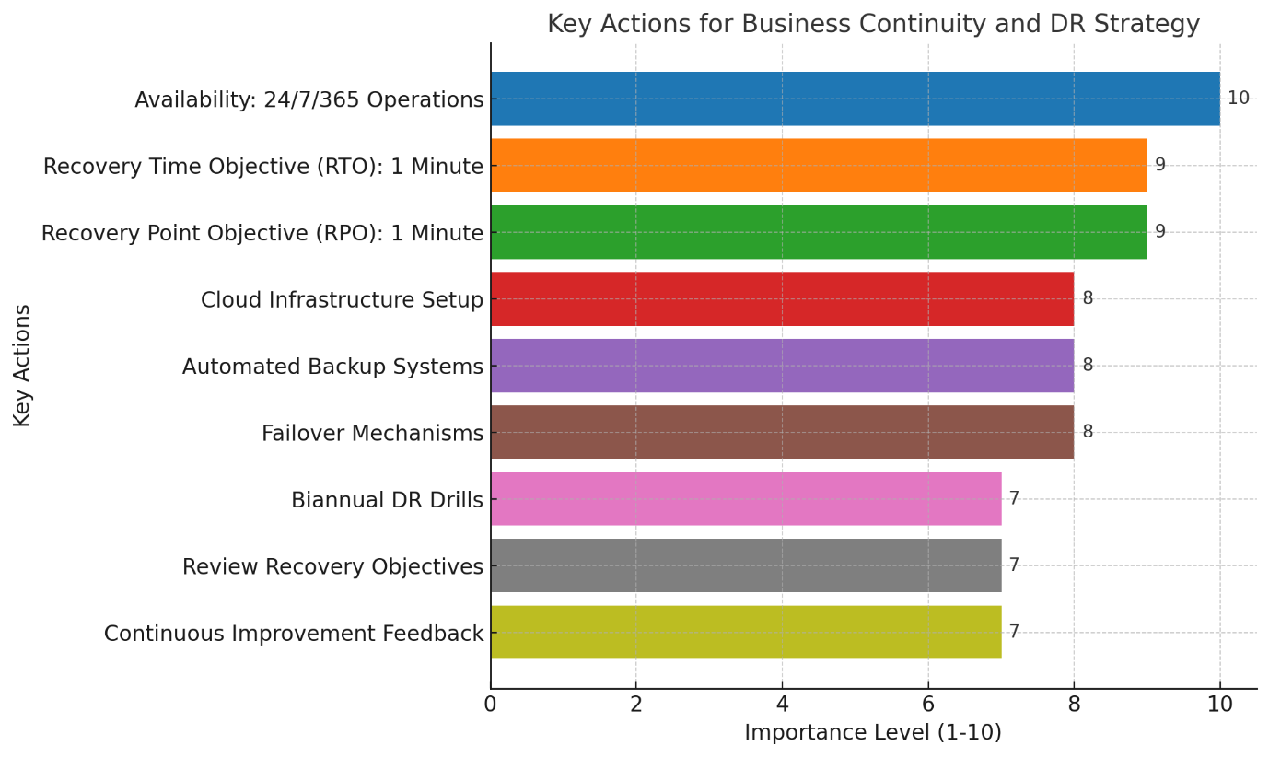

## 3.1 Disaster Recovery Planning

A hybrid cloud-based DR solution is recommended to meet these requirements. This approach combines public and private cloud infrastructures, ensuring scalable and reliable operations. Key steps include:

* **Cloud Infrastructure Setup:** Partner with reputable providers like AWS or Microsoft Azure to ensure high availability and redundancy.
* **Automated Backup Systems:** Deploy real-time data backup solutions to minimise data loss during an outage.
* **Failover Mechanisms:** Implement automated failover systems that seamlessly switch to backup servers during primary server disruptions.

## 3.2 DR Testing and Maintenance

Regular testing of DR protocols is critical to identifying vulnerabilities and ensuring system readiness. Key measures include:

* Conducting biannual DR drills to simulate potential disruptions and evaluate system response times.
* Reviewing recovery objectives and timelines to align with evolving business needs.
* Establishing a feedback loop for continuous improvement of DR strategies.

## 3.3 Communication and Stakeholder Engagement

A clear communication plan is essential to keep stakeholders informed during and after disruptions. This includes:

* Assigning resolute teams for internal and external communication.
* Providing real-time updates to clients and partners to maintain transparency.
* Training staff on DR protocols to ensure seamless execution during incidents.

# 4. Legal and Ethical Considerations

The implementation of digitalisation must align with global data protection standards, including GDPR compliance, while integrating ethical and sustainability considerations. This ensures compliance with regulatory requirements, enhances corporate social responsibility, and builds long-term stakeholder trust.

### 4.1 Data Privacy and Protection

Protecting data is fundamental in an era of increased reliance on digital ecosystems. Non-compliance with regulations such as the GDPR could result in severe reputational and financial consequences, with penalties of up to €20 million or 4% of annual global turnover (Cornell University, 2017).

**Approach:**

* **Encryption and Authentication:** Implement robust encryption protocols to secure data in transit and at rest. Two-factor authentication and tokenisation mechanisms should be standard for sensitive systems.
* **Regular Audits:** Conduct frequent audits to evaluate data handling processes and identify vulnerabilities. Such evaluations ensure ongoing adherence to GDPR principles, including data minimisation and accountability.
* **Vendor Accountability:** All third-party vendors must comply with GDPR through contractual agreements and regular compliance checks.
* **Example:** The UK’s Information Commissioner’s Office (ICO) cites Tesco's strong data protection practices in safeguarding customer information during its digital transformation initiatives (Cornell University, 2017).

## 4.2 Ethical Use of Artificial Intelligence (AI)

With increasing reliance on AI for quality control, inventory management, and decision-making, ethical considerations must guide AI deployment to avoid biases and ensure fairness. AI misuse can lead to reputational risks and operational inefficiencies (Yamamoto, 2020).

**Approach:**

* **Algorithm Audits:** Conduct periodic reviews of AI algorithms to identify potential biases and ensure equitable and transparent decisions.
* **Explainable AI:** Adopt frameworks that allow users to understand and challenge AI-driven decisions. This is crucial for maintaining trust in automated systems.
* **Employee Training:** Develop AI ethics training programmes to equip employees with the knowledge to monitor AI-driven operations responsibly.
* **Example:** Rolls-Royce responsibly uses AI for predictive maintenance, ensuring transparency and fairness in all AI-driven decision-making processes (Yamamoto, 2020).

## 4.3 Environmental Sustainability

The environmental impact of digitalisation, particularly from energy-intensive cloud operations and warehouses, must be mitigated to meet sustainability goals and align with CSR expectations.

**Approach:**

* **Renewable Energy Integration:** Transition to renewable energy sources for powering data centres and automated warehouses.
* **Energy Efficiency Measures:** To reduce operational energy consumption, implement energy-saving technologies, including smart sensors and optimised cooling systems.
* **Sustainable Logistics:** Use energy-efficient vehicles and optimise delivery routes to minimise emissions.
* **Green Certifications:** Aim for certifications such as ISO 14001 to demonstrate a commitment to sustainability.
* **Example:** BT Group’s investment in renewable energy for its operations showcases its leadership in sustainable digitalisation, reducing its carbon footprint by 25% in two years (Zaoui & Souissi, 2020).

## 4.4 Implementation Timeline

The Gantt chart provides a timeline for Cathy’s Disaster Recovery (DR) plan, prioritising foundational tasks to optimise resources and minimise disruptions:

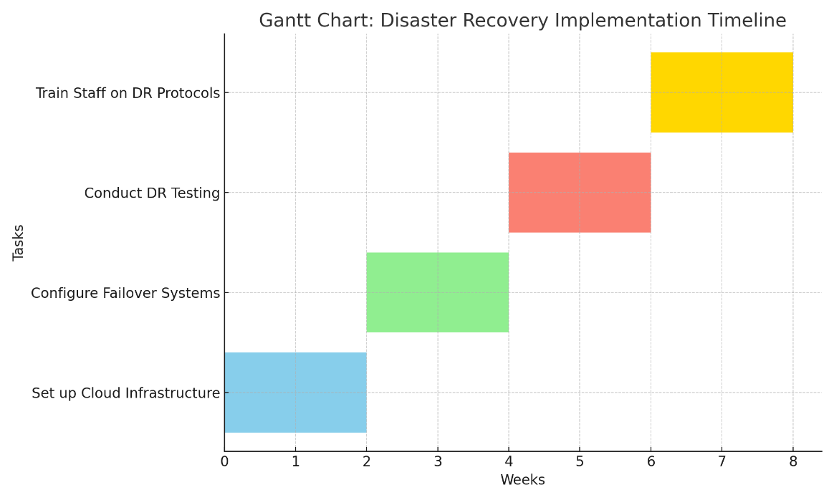

1. **Set Up Cloud Infrastructure (Weeks 1–2):** Establish scalable cloud systems with providers like AWS or Microsoft Azure to enable real-time backups and seamless failover capabilities.

Example: NIST (2015) highlights cloud infrastructure as critical for operational continuity.

1. **Configure Failover Systems (Weeks 3–4):** Implement automated failover systems to ensure uninterrupted operations during server disruptions.

Example: Kumar (2021) notes that automated failover mechanisms minimise downtime and ensure reliability.

1. **Conduct DR Testing (Weeks 5–6):** Simulate disruptions to validate the DR plan’s effectiveness, focusing on recovery time and data protection metrics.

Example: Forbes (2022) underscores the value of regular DR testing in reducing system vulnerabilities.

1. **Train Staff on DR Protocols (Weeks 7–8):** Equip employees with the skills to execute DR plans effectively and maintain stakeholder communication.

Example: Christopher (2016) highlights training as pivotal for reducing human error during emergencies.

This timeline prioritises critical infrastructure tasks, aligning with best practices for disaster recovery and ensuring operational resilience.

# 5. Conclusion

Cathy’s company should remain agile in its digital transformation strategy, continuously evaluating technological advancements and regulatory changes. By adopting an initiative-taking approach to innovation and adapting to shifting regulatory landscapes, the organisation ensures resilience in a competitive market. Furthermore, investing in sustainability and ethical practices meets compliance requirements and builds a solid foundation for stakeholder trust and long-term profitability.

Organisations that align their strategies with global initiatives like the UN’s Sustainable Development Goals (SDGs) often achieve enhanced reputation and market positioning (Zaoui & Souissi, 2020). By implementing robust DR strategies and adhering to regulatory standards such as GDPR, Cathy’s company can safeguard its operational integrity and deliver value to its stakeholders.

Additionally, prioritising a culture of sustainability and ethical decision-making provides a competitive edge, ensuring the organisation’s relevance in an increasingly interconnected world. As technology evolves, Cathy’s company should leverage advancements in AI, automation, and green technologies to enhance operational efficiency and customer satisfaction (PwC, 2018). By fostering innovation, mitigating risks, and embracing sustainable practices, the organisation is well-positioned to secure its leadership in the global market. By promoting a culture of innovation and sustainability, the organisation can mitigate risks and leverage opportunities to strengthen its position as a market leader (PwC, 2018).

## References

1. Beckett, C. (2008) ‘Working with Female Offenders’, in: Green, S., Lancaster, E. & Feasey, S. (eds) Addressing Offending Behaviour – Context, Practice and Values. Devon: Willan Publishing.
2. Cornell University (2017) Cloudification. [Online]. Available at: https://it.cornell.edu/cornell-cloud [Accessed 20 December 2024].
3. European Union Agency for Cybersecurity (2022) Cybersecurity Risk Assessment for Retail Businesses. [Online]. Available at: https://www.enisa.europa.eu [Accessed 20 December 2024].
4. Kumar, V. (2021) Vendor Lock-In in Cloud Environments. International Journal of Cloud Computing, 19(4), pp.250-270.
5. Yamamoto, S. (2020) A Strategic Map for Digital Transformation. Procedia Computer Science, 176, pp.1374-1381. DOI: 10.1016/j.procs.2020.09.147.
6. Zaoui, F. & Souissi, N. (2020) Roadmap for Digital Transformation: A Literature Review. Procedia Computer Science, 175, pp.621-628. DOI: 10.1016/j.procs.2020.07.090.
7. Christopher, M. (2016) Logistics & Supply Chain Management. 5th ed. Harlow: Pearson Education Limited.
8. World Bank (2023) Global Supply Chain Risk Report 2023. [Online]. Available at: https://www.worldbank.org [Accessed 20 December 2024].
9. Forbes (2022) Case Studies in Automated Warehouses: Risk Management in Digitalisation. [Online]. Available at: https://www.forbes.com [Accessed 20 December 2024].
10. Saunders, M., Lewis, P. & Thornhill, A. (2016) Research Methods for Business Students. 7th ed. Essex: Pearson Education Limited.
11. Ellram, L. M. (2013) ‘Offshoring, reshoring and the manufacturing location decision’, Journal of Supply Chain Management, 49(2), pp.3-5.
12. Statista (2024) E-Commerce in the United Kingdom (UK) - statistics and facts. [Online]. Available at: https://www.statista.com [Accessed 6 November 2024].
13. PwC (2018) Attract and Retain Customers with Digital Platforms. [Online]. Available at: https://www.pwc.com/us/en [Accessed 1 December 2024].
14. Zhang, Z. et al. (2021) ‘Cybersecurity awareness training programs: a cost-benefit analysis framework’, Industrial Management & Data Systems, DOI: 10.1108/IMDS-08-2020-0462.
15. SANS Institute (2018) Security Awareness Planning Kit. [Online]. Available at: https://www.sans.org/tools/security-awareness-planning-toolkit [Accessed 1 December 2024].
16. NIST (2015) Guide to Data-Centric System Threat Modeling. [Online]. Available at: https://www.nist.gov [Accessed 5 December 2024].
17. eMarketer (2020) Global Ecommerce Update 2020. [Online]. Available at: https://www.emarketer.com [Accessed 8 December 2024].